**Effect of gravity on height**

When I first heard this idea from Prax I got very excited: measuring the changes in height during the day due to gravity… such a non-sense experiment! What I didn´t know is that he really meant it: he was convinced that the gravity can swing our heights a few centimetres up and down every day. A few centimetres!

**So the idea is simple**: when you are standing, the gravity will exert more pressure in your longitudinal axis and you will shorten; on the contrary, when you are lying the gravity force will be perpendicular to you so you will elongate. Here is a simple depiction:

Photo is in your mobile

And I repeat: we are not talking about small changes in the microscale, **we are talking about various cm difference.**

I had to prove him wrong, so I accepted the challenge.

**Hypothesis**: **The height will decrease throughout the day more than 1 cm** *(due to the effect of gravity).*

Note that I wrote “*due to the effect of gravity*” into parenthesis because we can´t determine the actual cause of the height reduction. We still don´t have zero-gravity rooms.

* **Prax´s prediction:** yes, of course, height decreases with gravity a few cm every day and increases during the night while you sleep. Didn´t you know it?
* **Irene´s prediction:** bullshit.

**Methods**

Two height measurements we taken for each day: 1 before sleeping and 1 after waking up. Each measurement was repeated two to three times to have an estimation of the error. The experiment was conducted for 4 days.

The height measurement system consisted of the following items:

* A wall
* Measuring tape
* Tape (to tape the tape)
* The lid of a box
* A clipboard with a painted owl
* Pen and paper
* Determination to wake up together at the same time every day

The measuring method can be seen in the following images:



**Results**

So this is the raw data. We took 2 replicate measurements at 10:00 and at 00:00 for the following 4 days:



We calculated the mean and standard deviation for each of us at morning and night-time. Note that our awesome height measuring system had a very low error! (emoti with sunglasses).



Then, to see if the differences between morning height and night height were statistically significant, we did a t-test with 95% confidence interval.





Result… both were strongly significant!

**Our heights decreased around 2 cm during the day.** We were taller after waking up and shorter before going to sleep!!

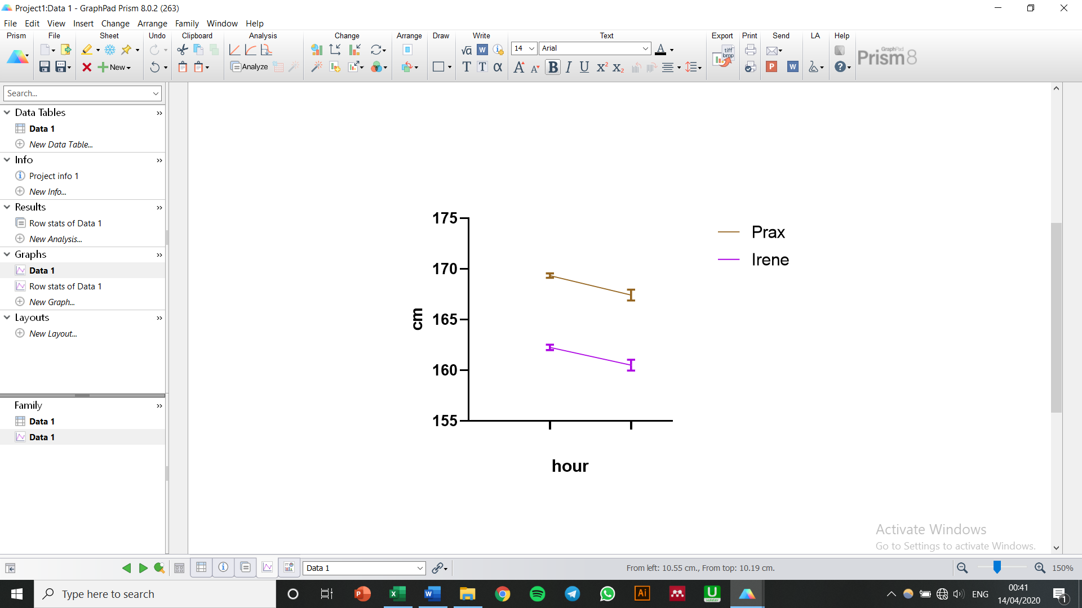

**\*\*\***

**\*\***

**10 00**